1c_bonus_A
Name: Jorune Simpkins
Date: 01/22/2026
Student Deliverables:
- Prove EC2 is private (no public IP)
aws ec2 describe-instances \
--instance-ids <INSTANCE_ID> \
--query "Reservations[].Instances[].PublicIpAddress"
Expected:
null
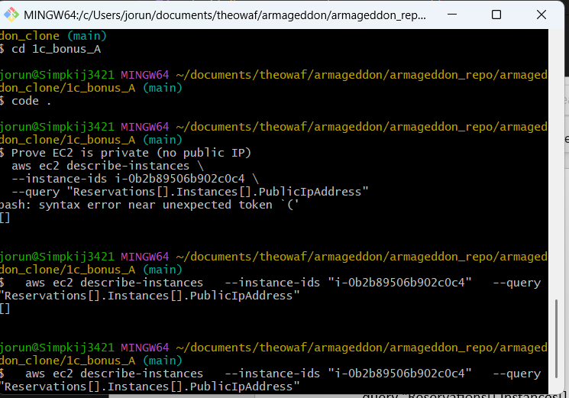

- Prove VPC endpoints exist
aws ec2 describe-vpc-endpoints \
--filters "Name=vpc-id,Values=<VPC_ID>" \
--query "VpcEndpoints[].ServiceName"

Expected: list includes:
ssm
ec2messages
ssmmessages
logs
secretsmanager
s3
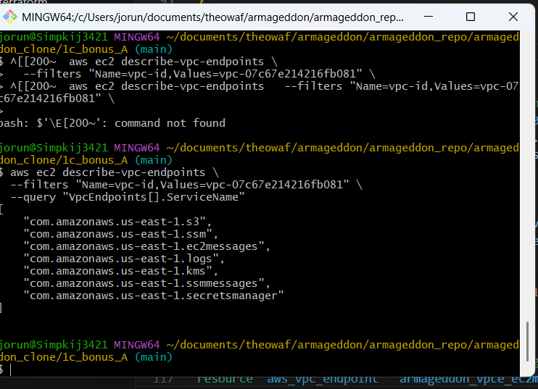
3) Prove Session Manager path works (no SSH)
aws ssm describe-instance-information \
--query "InstanceInformationList[].InstanceId"

Expected: your private EC2 instance ID appears
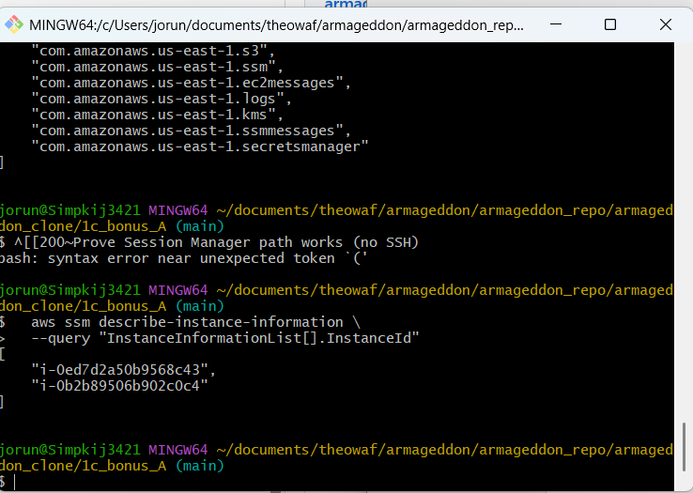

4) Prove the instance can read both config stores
Run from SSM session:
- aws ssm get-parameter --name /lab/db/endpoint
b.) aws secretsmanager get-secret-value --secret-id <your-secret-name>

4) Prove the instance can read both config stores
Run from SSM session:
- aws ssm get-parameter --name /lab/db/endpoint
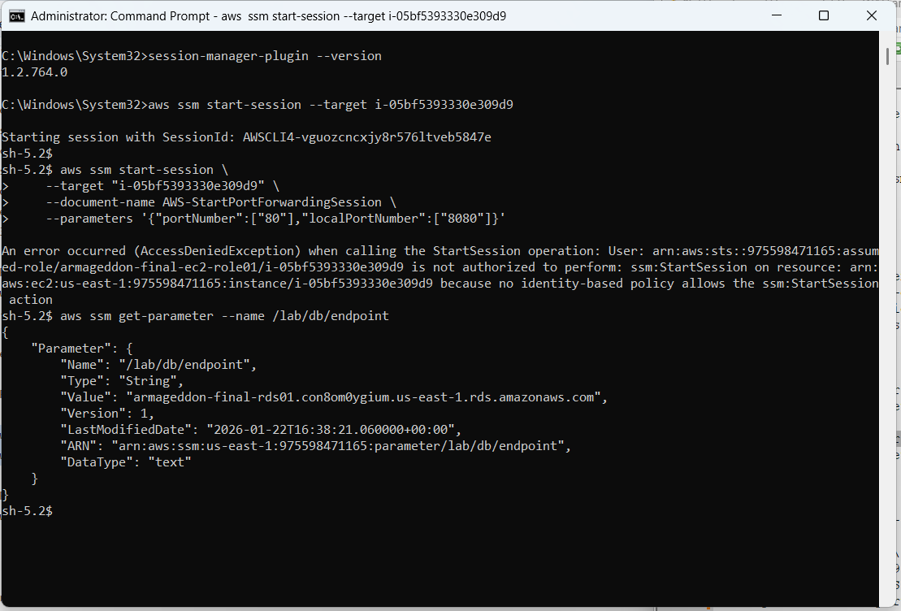

4) Prove the instance can read both config stores
Run from SSM session:
- aws secretsmanager get-secret-value --secret-id lab/rds/mysql
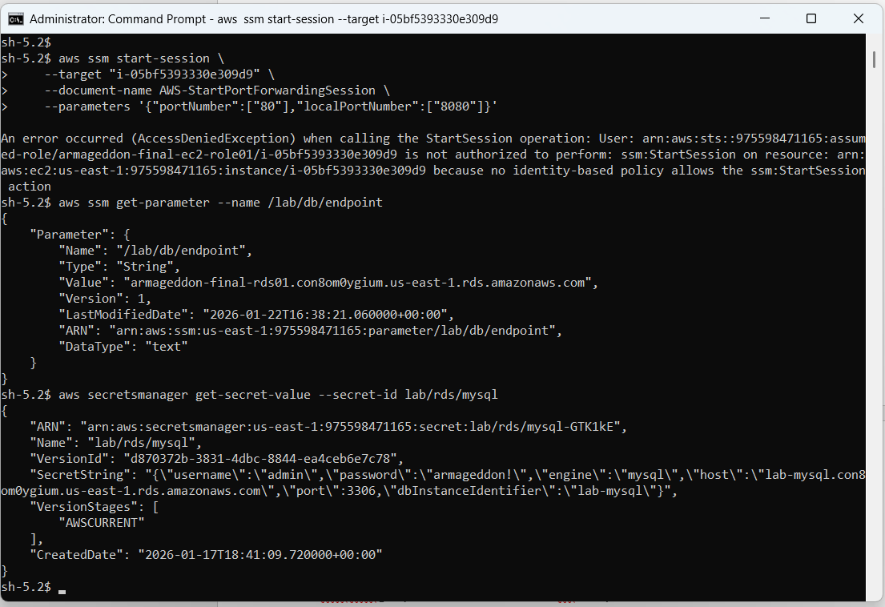

5) Prove CloudWatch logs delivery path is available via endpoint
aws logs describe-log-streams \
--log-group-name /aws/ec2/<prefix>-rds-app
